**Aggregation (HOLDS/ Part of life):**

* **I holds a car, I holds a apartment**
* **Provide a instance by factory, dependency inversion container (DI container)**

**Composition (contains/ uses/ has-a):**

* TempratureParameterValidator -> uses logger. (or) has a logger dependency
* Or -> TempratureParameterValidator **contains** the object of logger.
* Here Logger will die when the obj of the TempratureParameterValidator is destroyed
* Example: Human contains emotions -> emotions will dies when human dies.
* Violation of dependency inversion principal

Above code can be refactored as : (Strategy pattern)

**Strategy pattern:**

Here context -> TempratureValidator

**composite pattern**

Now lets say I want to add the constraint to add the multiple loggers like consoleLogger, FileLogger etc. i.e broadcasting to multiple -> i.e **composite pattern**

I.e One logger is now changing to many

When ever there is tree structure/ hierarchy we use composite pattern. Example XML parser, UI components

**Example 2: (composite Pattern)**

**Observer pattern:**

Observer pattern notes:

* One to many communication
* Say we need to update the order status via Email, SMS

**Mediator pattern**: (Many to many, Single spa applications, angular event emitter, RXJS, Rabbit Mq)

Here M1, M2, are the individual UI module.

In Enterprise applications:

* Event Aggregator is also called as the Event bus, Service Bus
* Pub sub model

**Bridge pattern**

* <https://www.codeproject.com/Articles/890/Bridge-Pattern-Bridging-the-gap-between-Interface>

**State pattern:**

Example: Bank account state handle

Example 2: Bug life cycle

<https://www.bugzilla.org/docs/2.18/html/lifecycle.html>

**Decorator pattern**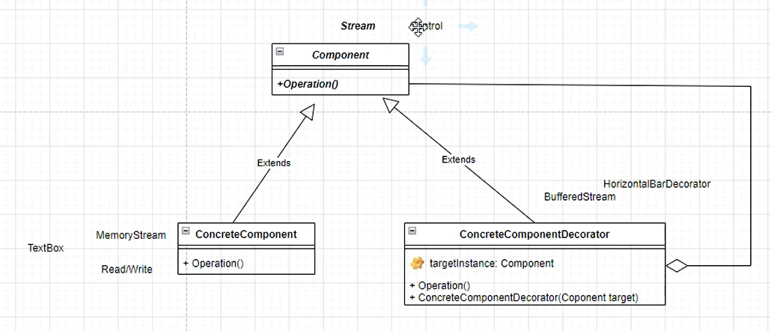

Chain of responsibilities

* Example: Interceptors

Adapter pattern:

Separator pattern (Same as object adapter) -> Command pattern

* Delegates in C# written using command pattern -> create delegate obj, and can be invoked any number of times. -> which method and which class need to be called.
* In Java we have Action listeners equivalent to delegates in c#
* Adapter will have intelligence -> it matchs the compatibility, command will just executes the command method just routes.

**Proxy pattern:**

Factory will create the real object and proxy object and then real object copies to proxy and then proxy object gives to client.

* Important: both proxy and real obj should be substitutable to each other.
* Mother acts as a proxy between me and father.
  + My father is the one who fullfill the needs by the request going via my mother instead of I directly ask him.
* SPRING AOP -> They don’t allow the obj directly -> handling the method when throws some exception, Aspect oriented programming(AOP) works on proxy

**Memento pattern.**

**Visitor pattern (last pattern, solves OCP principal)**

* **It also solves double dispatch problem.**
* **Example, stream parser, tree parser**
* Diagram

  Description automatically generated

**Dispatch problem:**

* **Question**

<https://github.com/venu-shastri/design-patterns-summary/blob/main/Dispatch-problem.cs>

* **Solution:**

<https://github.com/venu-shastri/design-patterns-summary/blob/main/DispactUsingVisitor.cs>

Cartesian product:

Every shape need to drawn on every plotter and plotter need the specific information of the shape. Solve it.

* Question:
  + <https://github.com/venu-shastri/design-patterns-summary/blob/main/CP.cs>
* Solution: (visitor pattern)

Output:

Drawing Rectangle shape using LaserPrinter, Rectangle parameters: R.H.W  
Drawing Rectangle shape using InkJetrinter, Rectangle parameters: R.H.W  
Drawing Circle shape using LaserPrinter, Circle parameters: C.R  
Drawing Circle shape using InkJetrinter, Circle parameters: C.R  
Drawing Polygon shape using LaserPrinter, Polygon parameters: P.S  
Drawing Polygon shape using InkJetrinter, Polygon parameters: P.S

Solution:

using System;

using System.Collections.Generic;

//Object Structure

public class Image{

public List<Shape> structure= new List<Shape>();

public void plot(List<ShapePoltter> plotters){

//M*N cartesian product

foreach(Shape s in structure){

foreach(ShapePoltter p in plotters){

s.plot(p);

}

}

}

}

public abstract class Shape{

public abstract void plot(ShapePoltter plotter);

}

public class Rectangle:Shape{

public string GeHeightAndWidth(){ return "R.H.W";}

public override void plot(ShapePoltter plotter) {

plotter.plot(this);

}

}

public class Circle:Shape{

public string GetRadius(){ return "C.R";}

public override void plot(ShapePoltter plotter) {

plotter.plot(this);

}

}

public class Polygon:Shape{

public string GetSides(){ return "P.S";}

public override void plot(ShapePoltter plotter) {

plotter.plot(this);

}

}

public abstract class ShapePoltter{

public abstract void plot(Rectangle shape);

public abstract void plot(Circle shape);

public abstract void plot(Polygon shape);

}

public class LaserPrinter : ShapePoltter{

public override void plot(Rectangle shape) {

Console.WriteLine("Drawing Rectangle shape using LaserPrinter, Rectangle parameters: " + shape.GeHeightAndWidth());

}

public override void plot(Circle shape) {

Console.WriteLine("Drawing Circle shape using LaserPrinter, Circle parameters: " + shape.GetRadius());

}

public override void plot(Polygon shape){

Console.WriteLine("Drawing Polygon shape using LaserPrinter, Polygon parameters: " + shape.GetSides());

}

}

public class InkJetrinter : ShapePoltter{

public override void plot(Rectangle shape) {

Console.WriteLine("Drawing Rectangle shape using InkJetrinter, Rectangle parameters: " + shape.GeHeightAndWidth());

}

public override void plot(Circle shape) {

Console.WriteLine("Drawing Circle shape using InkJetrinter, Circle parameters: " + shape.GetRadius());

}

public override void plot(Polygon shape){

Console.WriteLine("Drawing Polygon shape using InkJetrinter, Polygon parameters: " + shape.GetSides());

}

}

public class Program {

public static void Main() {

Shape rect = new Rectangle();

Shape circle = new Circle();

Shape polygon = new Polygon();

ShapePoltter laserPrinter = new LaserPrinter();

ShapePoltter inkJetrinter = new InkJetrinter();

Image image = new Image();

image.structure.Add(rect);

image.structure.Add(circle);

image.structure.Add(polygon);

List<ShapePoltter> plotters = new List<ShapePoltter>();

plotters.Add(laserPrinter);

plotters.Add(inkJetrinter);

// plotting all shapes

image.plot(plotters);

}

}

**Fly Weight:**

<https://javapapers.com/design-patterns/flyweight-design-pattern/>